Repeated Measures ANOVA

Introduction

Repeated measures ANOVA is the equivalent of the one-way ANOVA, but for related, not independent groups, and is the extension of the [dependent t-test](https://statistics.laerd.com/statistical-guides/dependent-t-test-statistical-guide.php). A repeated measures ANOVA is also referred to as a within-subjects ANOVA or ANOVA for correlated samples. All these names imply the nature of the repeated measures ANOVA, that of a test to detect any overall differences between related means. There are many complex designs that can make use of repeated measures, but throughout this guide, we will be referring to the most simple case, that of a one-way repeated measures ANOVA. This particular test requires one independent variable and one dependent variable. The dependent variable needs to be [continuous](https://statistics.laerd.com/statistical-guides/types-of-variable.php) (interval or ratio) and the independent variable categorical (either [nominal](https://statistics.laerd.com/statistical-guides/types-of-variable.php) or [ordinal](https://statistics.laerd.com/statistical-guides/types-of-variable.php)).

When to use a Repeated Measures ANOVA

We can analyse data using a repeated measures ANOVA for two types of study design. Studies that investigate either (1) changes in mean scores over three or more time points, or (2) differences in mean scores under three or more different conditions. For example, for (1), you might be investigating the effect of a 6-month exercise training programme on blood pressure and want to measure blood pressure at 3 separate time points (pre-, midway and post-exercise intervention), which would allow you to develop a time-course for any exercise effect. For (2), you might get the same subjects to eat different types of cake (chocolate, caramel and lemon) and rate each one for taste, rather than having different people flavour each different cake. The important point with these two study designs is that the same people are being measured more than once on the same dependent variable (i.e., why it is called repeated measures).

In repeated measures ANOVA, the independent variable has categories called **levels** or **related groups**. Where measurements are repeated over time, such as when measuring changes in blood pressure due to an exercise-training programme, the independent variable is **time**. Each **level** (or **related group**) is a specific time point. Hence, for the exercise-training study, there would be three time points and each time-point is a level of the independent variable (a schematic of a time-course repeated measures design is shown below):

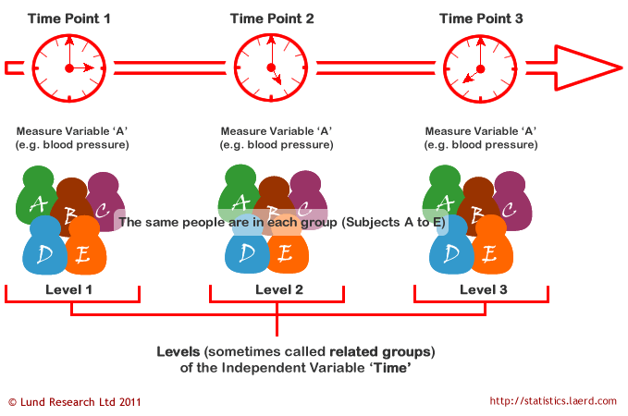

Where measurements are made under different conditions, the conditions are the levels (or related groups) of the independent variable (e.g., type of cake is the independent variable with chocolate, caramel, and lemon cake as the levels of the independent variable). A schematic of a different-conditions repeated measures design is shown below. It should be noted that often the levels of the independent variable are not referred to as conditions, but **treatments**. Which one you want to use is up to you. There is no right or wrong naming convention. You will also see the independent variable more commonly referred to as the **within-subjects factor**.

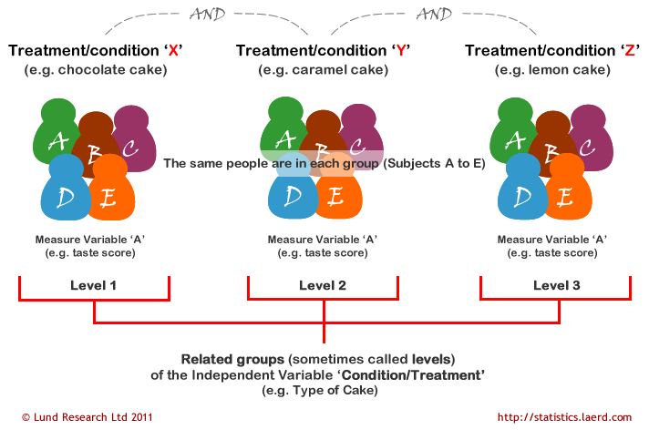

The above two schematics have shown an example of each type of repeated measures ANOVA design, but you will also often see these designs expressed in tabular form, such as shown below:

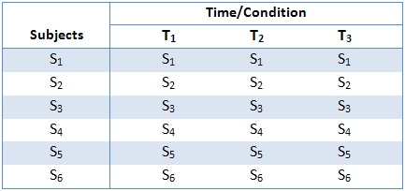

This particular table describes a study with six subjects (S1 to S6) performing under three conditions or at three time points (T1 to T3). As highlighted earlier, the within-subjects factor could also have been labelled "treatment" instead of "time/condition". They all relate to the same thing: subjects undergoing repeated measurements at either different time points or under different conditions/treatments.

Hypothesis for Repeated Measures ANOVA

The repeated measures ANOVA tests for whether there are any differences between related population means. The null hypothesis (H0) states that the means are equal:

*H0: µ1 = µ2 = µ3 = … = µk*

where *µ* = population mean and *k* = number of related groups. The alternative hypothesis (HA) states that the related population means are not equal (at least one mean is different to another mean):

*HA: at least two means are significantly different*

For our exercise-training example, the null hypothesis (H0) is that mean blood pressure is the same at all time points (pre-, 3 months, and 6 months). The alternative hypothesis is that mean blood pressure is significantly different at one or more time points. A repeated measures ANOVA will not inform you where the differences between groups lie as it is an omnibus statistical test. The same would be true if you were investigating different conditions or treatments rather than time points, as used in this example. If your repeated measures ANOVA is statistically significant, you can run post hoc tests that can highlight exactly where these differences occur. How to run appropriate post-hoc tests for a repeated measures ANOVA in SPSS can be found ([here](https://statistics.laerd.com/spss-tutorials/one-way-anova-repeated-measures-using-spss-statistics-2.php)).

Logic of the Repeated Measures ANOVA

The logic behind a repeated measures ANOVA is very similar to that of a between-subjects ANOVA. Recall that a between-subjects ANOVA partitions total variability into between-groups variability (SSb) and within-groups variability (SSw), as shown below:

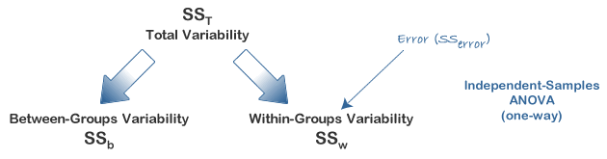

In this design, within-group variability (SSw) is defined as the error variability (SSerror). Following division by the appropriate degrees of freedom, a mean sum of squares for between-groups (MSb) and within-groups (MSw) is determined and an *F*-statistic is calculated as the ratio of MSb to MSw (or MSerror), as shown below:

 statistic for an independent ANOVA

A repeated measures ANOVA calculates an *F*-statistic in a similar way:

 statistic for a Repeated Measures ANOVA

The advantage of a repeated measures ANOVA is that whereas within-group variability (SSw) expresses the error variability (SSerror) in an independent (between-subjects) ANOVA, a repeated measures ANOVA can further partition this error term, reducing its size, as is illustrated below:

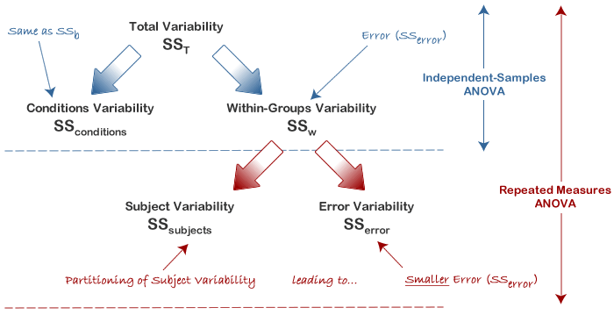

This has the effect of increasing the value of the *F*-statistic due to the reduction of the denominator and leading to an increase in the power of the test to detect significant differences between means (this is discussed in more detail later). Mathematically, and as illustrated above, we partition the variability attributable to the differences between groups (SSconditions) and variability within groups (SSw) exactly as we do in a between-subjects (independent) ANOVA. However, with a repeated measures ANOVA, as we are using the same subjects in each group, we can remove the variability due to the individual differences between subjects, referred to as SSsubjects, from the within-groups variability (SSw). How is this achieved? Quite simply, we treat each subject as a block. That is, each subject becomes a level of a factor called subjects. We then calculate this variability as we do with any between-subjects factor. The ability to subtract SSsubjects will leave us with a smaller SSerror term, as highlighted below:

rror Comparison between an Independent vs. Repeated Measures ANOVA

Now that we have removed the between-subjects variability, our new SSerror only reflects individual variability to each condition. You might recognise this as the interaction effect of subject by conditions; that is, how subjects react to the different conditions. Whether this leads to a more powerful test will depend on whether the reduction in SSerror more than compensates for the reduction in degrees of freedom for the error term (as degrees of freedom go from (*n - k*) to (*n - 1*)(*k - 1*) (remembering that there are more subjects in the independent ANOVA design).

Calculating a Repeated Measures ANOVA

In order to provide a demonstration of how to calculate a repeated measures ANOVA, we shall use the example of a 6-month exercise-training intervention where six subjects had their fitness level measured on three occasions: pre-, 3 months, and post-intervention. Their data is shown below along with some initial calculations:

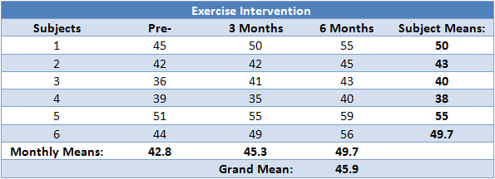

The repeated measures ANOVA, like other ANOVAs, generates an *F*-statistic that is used to determine statistical significance. The *F*-statistic is calculated as below:

ormula for the F-statistic for a Repeated Measures ANOVA

You will already have been familiarised with SSconditions from earlier in this guide, but in some of the calculations in the preceding sections you will see SSconditions sometimes referred to as SStime. They both represent the sum of squares for the differences between related groups, but SStime is a more suitable name when dealing with time-course experiments, as we are in this example. The diagram below represents the partitioning of variance that occurs in the calculation of a repeated measures ANOVA.

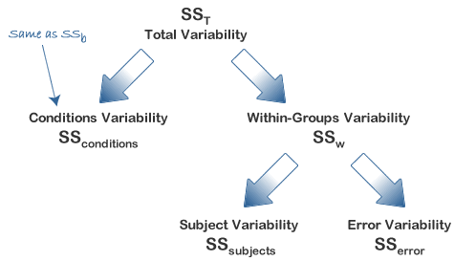

In order to calculate an *F*-statistic we need to calculate SSconditions and SSerror. SSconditions can be calculated directly quite easily (as you will have encountered in an independent ANOVA as SSb). Although SSerror can also be calculated directly it is somewhat difficult in comparison to deriving it from knowledge of other sums of squares which are easier to calculate, namely SSsubjects, and either SST or SSw. SSerror can then be calculated in either of two ways:

ifferences between error terms for independent and Repeated Measures

Both methods to calculate the *F*-statistic require the calculation of SSconditions and SSsubjects but you then have the option to determine SSerror by first calculating either SST or SSw. There is no right or wrong method, and other methods exist; it is simply personal preference as to which method you choose. For the purposes of this demonstration, we shall calculate it using the first method, namely calculating SSw.

*Join the 10,000s of students, academics and professionals who rely on Laerd Statistics.*[**TAKE THE TOUR**](https://statistics.laerd.com/features-overview.php) [**PLANS & PRICING**](https://statistics.laerd.com/pricing.php)

Calculating SStime

As mentioned previously, the calculation of SStime is the same as for SSb in an independent ANOVA, and can be expressed as:

ifferences between error terms for independent and Repeated Measures

where *k* = number of conditions, *ni* = number of subjects under each (ith) condition, ean of ith term = mean score for each (ith) condition, ean = grand mean. So, in our example, we have:

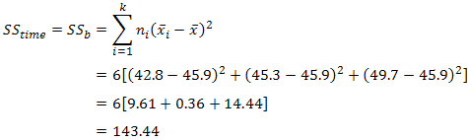

Notice that because we have a repeated measures design, *ni* is the same for each iteration: it is the number of subjects in our design. Hence, we can simply multiple each group by this number. To better visualize the calculation above, the table below highlights the figures used in the calculation:

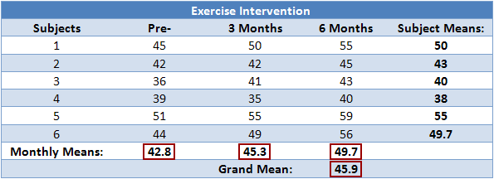

Calculating SSw

Within-groups variation (SSw) is also calculated in the same way as in an independent ANOVA, expressed as follows:

ormula for Sum of Squares for Within Groups

where xi1 is the score of the ith subject in group 1, xi2 is the score of the ith subject in group 2, and xik is the score of the ith subject in group k. In our case, this is:

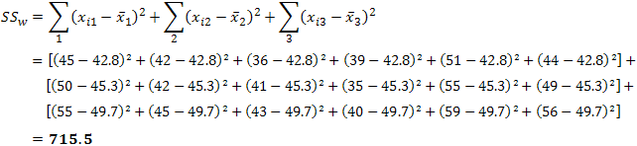

To better visualize the calculation above, the table below highlights the figures used in the calculation:

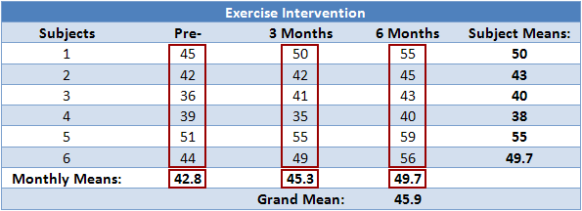

Calculating SSsubjects

As mentioned earlier, we treat each subject as its own block. In other words, we treat each subject as a level of an independent factor called subjects. We can then calculate SSsubjects as follows:

ormula for Sum of Squares for Subjects

where k = number of conditions, ean of ith term mean of subject *i*, and ean = grand mean. In our case, this is:

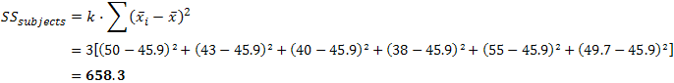

To better visualize the calculation above, the table below highlights the figures used in the calculation:

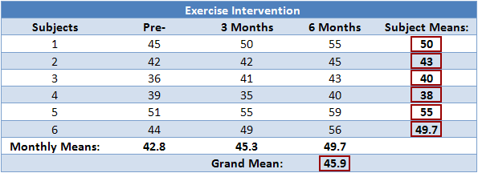

Calculating SSerror

We can now calculate SSerror by substitution:

ormula for Sum of Squares for Error

which, in our case, is:

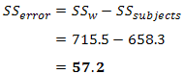

Determining MStime, MSerror and the *F*-statistic

To determine the mean sum of squares for time (MStime) we divide SStime by its associated degrees of freedom (*k - 1*), where *k* = number of time points. In our case:

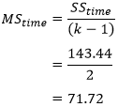

We do the same for the mean sum of squares for error (MSerror), this time dividing by (*n - 1*)(*k - 1*) degrees of freedom, where *n* = number of subjects and *k* = number of time points. In our case:

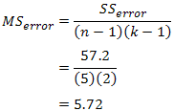

Therefore, we can calculate the *F*-statistic as:

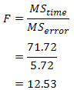

We can now look up (or use a computer programme) to ascertain the critical *F*-statistic for our *F*-distribution with our degrees of freedom for time (dftime) and error (dferror) and determine whether our *F*-statistic indicates a statistically significant result.

We can now look up (or use a computer programme) to ascertain the critical *F*-statistic for our *F*-distribution with our degrees of freedom for time (dftime) and error (dferror) and determine whether our *F*-statistic indicates a statistically significant result.

Reporting the Result of a Repeated Measures ANOVA

We report the *F*-statistic from a repeated measures ANOVA as:

*F*(dftime, dferror) = *F*-value, *p* = *p*-value

which for our example would be:

*F*(2, 10) = 12.53, *p* = .002

This means we can reject the null hypothesis and accept the alternative hypothesis.: